Empty Homes Deep Dive – North
held on Thursday 15 August 2024 – 9:00am – 15:00pm
at Southwick Training Room
PRESENT |  | IN ATTENDANCE
Susan (SC)  Sandra (SB)  Diane (DC) |  | Lewis Walmsley (LW) – Customer Engagement Lead  Zoe Lambert (ZL) – Operations Manager (Empty Homes)  Gareth Wynn (GW) – Repairs & Maintenance Manager - VOIDs  Mark Robson (MR) – Repairs & Maintenance Manager - VOIDs
PARA |  |  | ACTION
 | - Introduction – Empty Homes Deep Dive
LW provided a round of introductions with all colleagues explaining their role within the organisation.

LW explained the purpose of todays session was to provide customers with the opportunity to scrutinise our empty homes and provide recommendations for improvement. LW advised members that the group have experienced a recent increase in complaints from those customers who have just moved in, therefore wanted to review the lettable standard to ensure it was fit for purpose.

ZL delivered a presentation on empty homes to members. This included an explanation of the empty homes process which can be found below:

- ZL explained all customers are required to provide a 28-day notice period (as per tenancy agreement) however, this does not apply to those customers who are moving from one Gentoo property too another.

- ZL advised the NC will then complete a pre-termination visit with the outgoing customer. This is to ensure there have been no unauthorised alterations or damage to the property. ZL advised any concerns identified would either warrant a chargeable repair, or the customer reverting any alterations back to the original condition. ZL acknowledged some customers will not allow us into their home and therefore, we are unable to complete an inspection until the keys have been returned.

ZL explained in the instances where a customer is transferring from one Gentoo property too another, we will follow the same process and any issues may prevent a move from going ahead.

- ZL advised a mutually agreed date will be arranged with the customer to collect keys and complete a final check of the property. If actions have not been completed as agreed at the pre-termination visit, the customer may be informed chargeable repairs will be raised.

- ZL explained once the keys are received, the Empty Property Officer will complete an inspection of the property and identify works which need to be completed as part of the VOID.

- ZL advised repairs will then be completed and property cleaned.

- ZL explained property will then be returned to the local housing team.

- ZL advised property will then be allocated to successful applicant.

ZL then provided members with the empty home figures which are below:

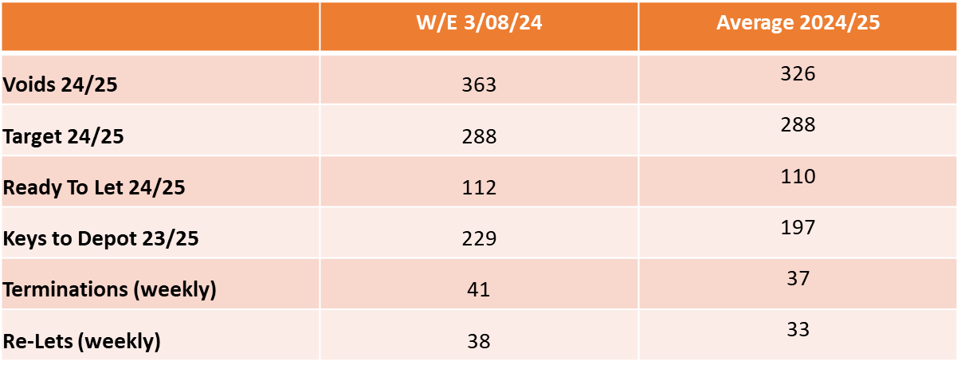

ZL explained we have 363 VOID properties in total, with 112 of them currently Ready to Let. ZL advised the figures change daily.

ZL provided members with some context to the volume of VOIDs her Empty Homes team deal with, explaining that in the last financial year, the team completed works on 1904 empty homes.

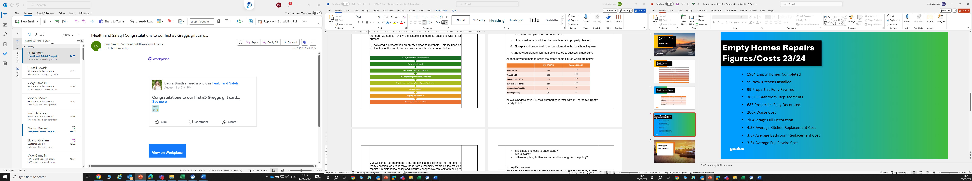

ZL advised the £200,000 waste cost is an area of concern, as this is customers rent which could be spent on improving VOID conditions, however, due to the items / condition some properties are left in, we are at times left with no option but to pay for this.

ZL advised there is a new piece of legislation called POPs. This means any upholstered furniture cannot be disposed of in general waste and we are required to pay £70 to dispose of each item. ZL advised this has come at a considerable cost to the business within the last 12 months.

ZL confirmed her team are trying to work smarter, as previously we would remove everything within an empty home, however, we will now leave carpets / flooring if they are in good condition and items of furniture if required. ZL advised they are going to start work with CSS furniture from 1 September to see if they can recycle items on our behalf. Further information can be found below.

https://www.csshelp.org/furniture-service

 | - Visits to Empty Homes
LW requested members pick 4 properties from a list of empty homes. LW advised these properties would be at different stages of the VOID process. This would include:

- Keys which were recently returned from the customer.
- Keys which were recently returned from the empty homes team.

LW provided members with the Lettable Standard (appendix 1) as well as a VOID scorecard (appendix 2). It was requested that members rate the condition of each property and on return to the office, we would discuss findings.

Photos taken from visits can be found on (appendix 3).

Members collectively picked the following properties to visit:

Bayswater Avenue (Returned from Empty Homes Team)
Conway Road (Returned from Empty Homes Team)
Campbell Road (Returned from Customer)
Rishton Square (Returned from Empty Homes Team)
Everest Square (Returned from Customer)
Clarendon Square (Returned from Customer)

Feedback from members below:

Bayswater Avenue

- Property was ready to let. Members agreed the property met a lettable standard Members commented that the window panels in the kitchen and bedroom required renewing as the seals had blown. MR confirmed an order would be raised to get these replaced, however all agreed it would not prevent a customer from moving in.

Gardens also required cutting back. MR explained Grounds Maintenance would be responsible for this and they would provide a cut, however this may occur once a customer has moved in. All agreed this would be acceptable.

Conway Road

- Property was ready to let. Members agreed the property met a lettable standard. Concerns were again raised regarding the garden as this required a cut.

Members commented on the colour of the bathroom; however, it was explained this would not be renewed due to it being in working order. ZL explained bathroom would be on a modernisation programme for renewal.

Campbell Road

- Keys recently received from customer, therefore Empty Homes Team yet to start work on the property. Members were shocked at the condition the property was left in. GW advised it is going to cost roughly £20,000 to bring the property back upto an acceptable standard.

Rishton Square

- Property was ready to let. All members agreed the property met a lettable standard. Members commented that there were marks in the bath. MR advised a job had been raised for Finishing Touches to attend and rectify this, however this may occur once a customer has moved in. SC & SB commented on the radiator not painted very well in the bedroom.

Everest Square

- Keys recently received from customer, therefore Empty Homes Team yet to start work on the property. A clearance of the property was taking place by contractors at the time. Members commented on the number of items which had been left.

Clarendon Square

- Keys recently received from customer, therefore Empty Homes Team yet to start work on the property. A clearance of the property was taking place by contractors at the time. Again, members commented on the number of items which had been left. Concerns were raised regarding the condition of the fascia board. It was advised this would be picked up on an external decoration programme, as was similar across the estate.

 | - Feedback following Visits
LW took feedback from all customers following the visits. All members agreed they were impressed with the property condition of those homes which were ready to let.

SC explained customers’ expectations have increased when it comes to the condition of property, however they also need to consider the overall cost to the group to improve standards.

DC advised while the condition of the properties internally have been to a good standard, the externals on some properties could give customers the wrong impression. DC commented on the condition of the facia at Clarendon Square and the gardens not being cut at some properties. ZL advised there are some trades which the Empty Homes team do not have within their remit, such as roofers / bricklayers / grounds maintenance operatives therefore it is possible some works will not be completed until the customer has moved in. ZL advised it is essential we communicate this with the customer moving into a property.

Members were advised that we currently decorate properties (where necessary) with magnolia paint. This is to provide customers with a base coat. Members were asked their views on this. Members advised a white coat would make the house feel fresher than using magnolia, however understood that using white paint would be more time consuming (as more coats may be required).

Members were asked about the information within the lettable standard. Members agreed they were happy with the content that was included.

DC asked if floorboards are checked within an empty home. ZL explained we would not necessarily lift a carpet to check, as we may not be able to re-lay the carpet, however we ensure all areas are walked over.
 | Next Steps
LW & ZL confirmed they had a further 2 sessions they were running across the City to seek further feedback and to ensure there is a consistency in the service in which the EH team deliver.

LW confirmed there would be a further session as the deep dive does not end here. LW advised the lettable standard would be re-designed and will require customer input on this. LW also advised members that Gentoo want to ensure continuous feedback is received from customers regarding the condition of their new home, as we are not receiving regular feedback due to a lack of engagement from customers. We therefore want to create a new survey in which our involved customers design the questions.
 | Date of Next Session
 | Tuesday 17 September – 10:00am – 12:00pm - Emperor House Board Room

Appendix 1 – Gentoo’s Lettable Standard

Appendix 2 – Rate our Voids Scoresheet

Appendix 3 – Photos from North’s Empty Homes Deep Dive

