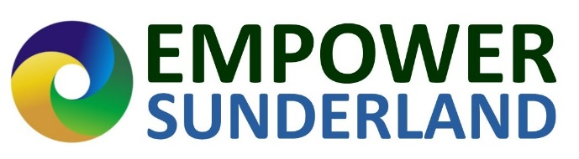
Monitoring and Evaluation Form – 12 Months
Name:
Organisation:
Amount awarded:
Date:
Savings made in the last 12 months £:
Savings made in the last 12 months Kwh: (if applicable)
How many people have benefited from the project/activity in the last 12 months:
How have the savings been passed on to the wider community so far?
Other Key monitoring information from your application:

Any additional information including:

-Pictures of the project.

-Quotes from community members or team members who have benefited from the project or activity.

-Any additional benefits that have happened as a result of the project or activity.

-Any final monitoring or evaluation thoughts at the end of the 12 month period?

Declaration
I confirm that I am authorised to sign this declaration and confirm that, to the best of my knowledge, all information is accurate.

Signature....................................................................

Name/ Position...........................................................

Date:………………………………………………………

